Main Method in Java

The main() is the starting point for JVM to start execution of a Java program. Without the main() method, JVM will not execute the program. It is a default signature which is predefined in the JVM. It is called by JVM to execute a program line by line and end the execution after completion of this method. We can also overload the main() method. The main method in Java belongs to a class but not to an Object. Objects are created at run time. Thus because the main main()in Java is the start point in your application, there is no way to start your application from an instance specific method. That is why the static keyword make perfect sense with the main method.

Main Method without String args[]
The program will compile, but not run, because JVM will not recognize the main() method. Remember JVM always looks for the main() method with a string type array as a parameter.

Execution of Main method

First, JVM executes the static block, then it executes static methods, and then it creates the object needed by the program. Finally, it executes the instance methods. JVM executes a static block on the highest priority basis. It means JVM first goes to static block even before it looks for the main() method in the program. When you start a Java program you usually do so via the command line (console). You call the java command that comes with the JRE, and tells it what Java class to execute, and what arguments to pass to the main() method. The Java application is then executed inside the JVM (or by the JVM some would claim). Here is a diagram illustrating this:
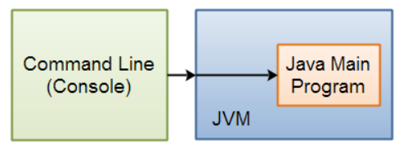
We can also overload the main() method. We can define any number of main() method in the class, but the method signature must be different.
The C and C++ programs which return int from main are processes of Operating System. The int value returned from main in C and C++ is exit code or exit status. The exit code of C or C++ program illustrates, why the program terminated. Exit code 0 means successfull termination. However, non zero exit status indicates error. Eg, exit code 1 depicts Miscellaneous errors, such as “divide by zero”
Parent process of any child process keeps waiting for exit status of child. And after receiving the exit status of child, cleans up the child process from process table and frees the resources allocated to it. Which is why it becomes mandatory for C and C++ programs(which are prcoesses of OS) to pass its exit status from main explicitly or implicitly.
However, The java program runs as main thread’ in JVM. The Java program is not even a process of Operating System directly. There is no direct interaction between Java program and Operating System. There is no direct allocation of resources to Java program directly, or the Java program does not occupy any place in process table. Whom should it return exit status to, then. Which is why main method of Java is designed not to return int or exit status.
But JVM is a process of a operating system, and JVM can be terminated with certain exit status. With help of java.lang.Runtime.exit(int status) or System.exit(int status)

